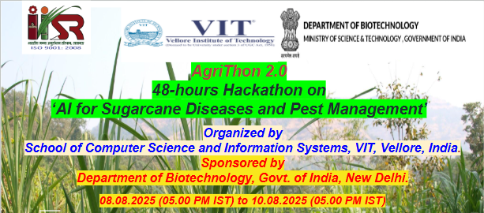

Hackathon Registration Form

Instructions to the participants:
- Download this form from the File Menu
- Fill it and upload

Name of the Team | SPROUT STACK

Team member’s details:

Team | Member-1  (Team Leader) | Member-2 | Member-3 | Member-4
Member Name | VK SHRIDHARAN | M AKILAN | S M MAKESH KAARTHIK | V PRATYUSH KUMAR
Gender | MALE | MALE | MALE | MALE
Date of Birth | 26.04.2005 | 06.03.2006 | 29.09.2005 | 23.06.2005
College Name with Full Address | VIT, Vellore Campus, Tiruvalam Rd, Katpadi, Vellore, Tamil Nadu 632014 | VIT, Vellore Campus, Tiruvalam Rd, Katpadi, Vellore, Tamil Nadu 632014 | VIT, Vellore Campus, Tiruvalam Rd, Katpadi, Vellore, Tamil Nadu 632014 | VIT, Vellore Campus, Tiruvalam Rd, Katpadi, Vellore, Tamil Nadu 632014
Current Year of Study | 3rd year | 3rd year | 3rd year | 3rd year
Course/Degree Name  (B.Tech/M.Tech/ B.C.A/M.C.A/ B.Sc./M.Sc./Others) | B.Tech CSE Core | B.Tech CSE Core | B.Tech CSE Core | B.Tech CSE IoT
Email ID | shridharan.vk2023@vitstudent.ac.in  shrivit27@gmail.com (personal id) | akilan.m2023@vitstudent.ac.in | makeshkaarthik.sm2023@vitstudent.ac.in | pratyushkumar.v2023@vitstudent.ac.in
Mobile Number | 7550249333 | 8122638900 | 9489149164 | 8778348357
Any Previous Experience (Projects/ Hackathons/ Hands-on events, etc.) | Had attended technical fest coding challenge. | Project: Costume trial estimation with 2-D image.  Event on Digit squad club. | Had attended Reverse coding Hackathon | Had attended hackathons.  Project:  Financial Statement Parser and Analytics Engine

Paste your College ID Card (two sides)
(Participants must bring their College ID Card)
Member-1  (Team Leader) | 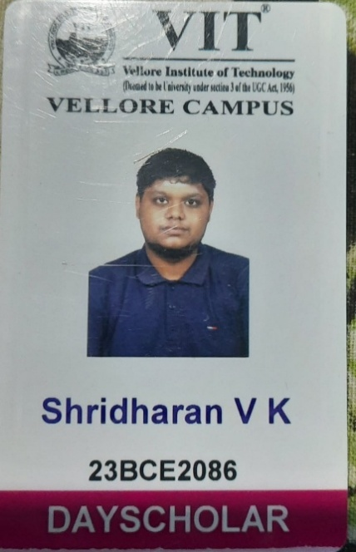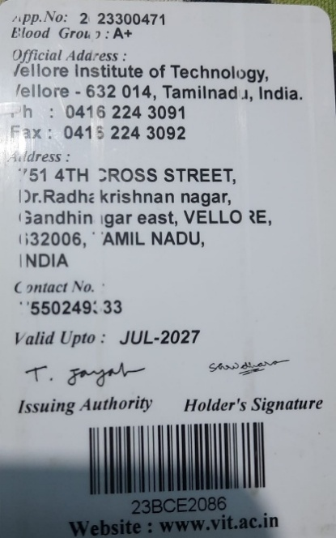
Member-2 | 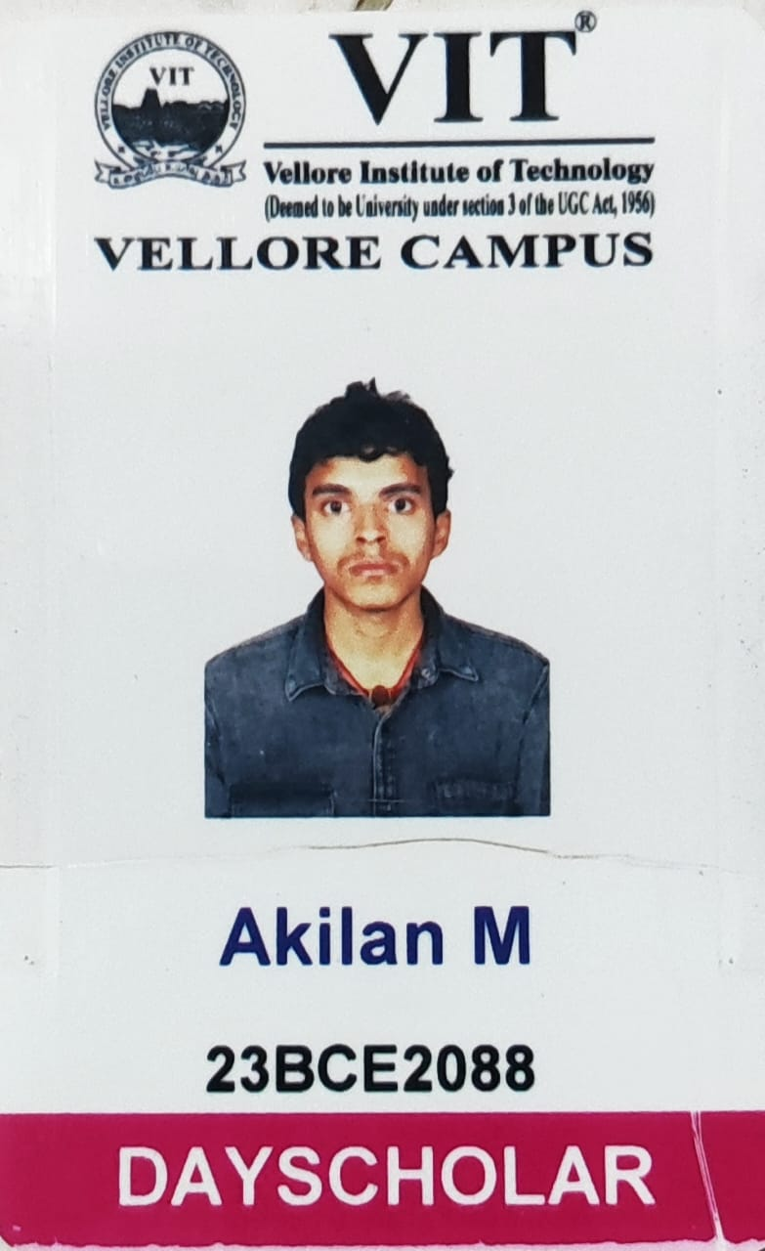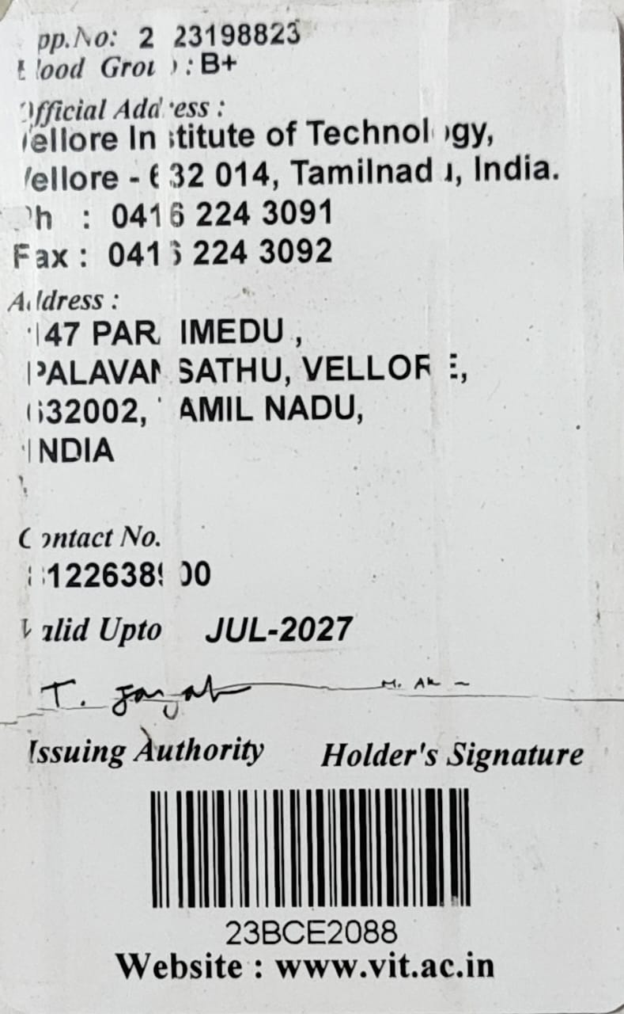
Member-3 | 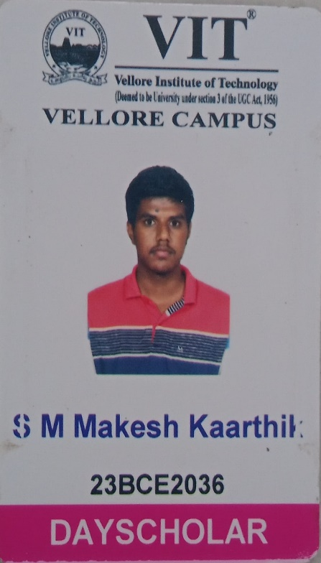  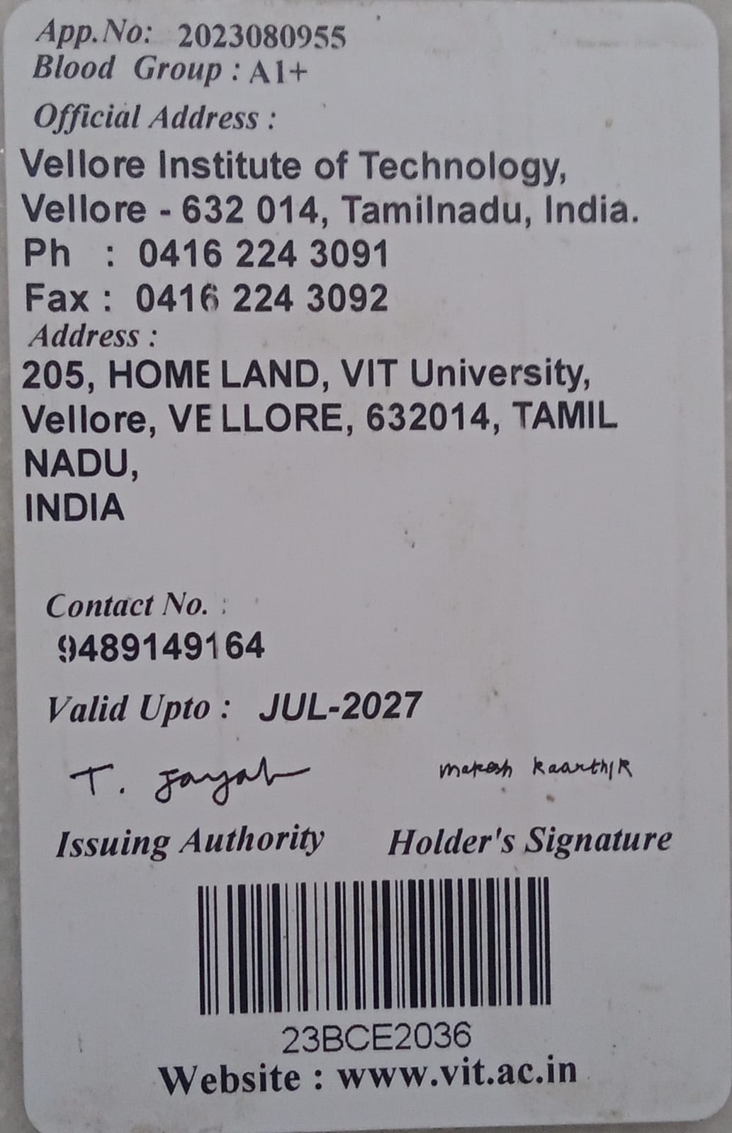
Member-4 | 